

Year 9 Science
Biology 2 Test: Ecology

SECTION 1: MULTIPLE CHOICE (1 mark each)
Circle your answer on the multiple choice answer sheet.

- Which of these is not a biotic factor in an ecosystem?
  - sunshine
  - predators
  - competition
  - commensalism

- In an ecosystem, producers are those things that
  - make their own food.
  - are eaten by consumers.
  - eat decaying material.
  - eat other organisms.

- Animals that kill and eat other animals are called
  - consumers.
  - predators.
  - omnivores.
  - scavengers.

- In an ecosystem, the species that there are fewest of, or have the smallest biomass are
  - the producers.
  - the first order (primary) consumers.
  - the second order (secondary) consumers.
  - the higher order consumers.

- Which of these is another name for a first order (primary)consumer?
  - plant
  - herbivore
  - carnivore
  - omnivore

- The origin of all energy in an ecosystem is
  - plants.
  - the sun.
  - heat.
  - animals.

- Residual chemicals, such as the banned pesticide DDT, are concentrated in the body tissues of animals that eat it. The higher up the food chain, the higher their body tissue concentrations will be. This is called
  - sustainability.
  - biodiversity.
  - biomagnification.
  - natural selection.

The next three questions refer to the following diagram

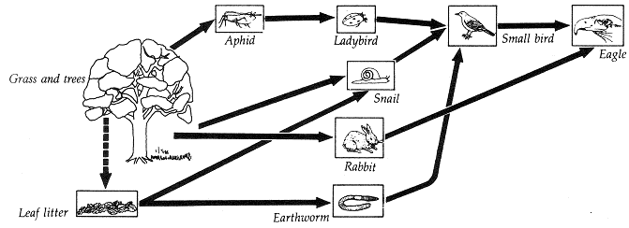

- The producer(s) in this ecosystem are
  - grass and trees.
  - leaf litter.
  - aphids, rabbits and snails.
  - eagle

- The ladybird is
  - a primary consumer.
  - a secondary consumer.
  - a tertiary consumer.
  - an omnivore.

- Which organism is a decomposer?
  - leaf litter
  - earthworm
  - eagle
  - small bird

- Eventually, all energy that enters an ecosystem will be lost in the form of
  - sunlight.
  - heat.
  - electricity.
  - carbon.

12. From the following lists, choose the one that only contains physical (abiotic) factors.
- rainfall, sunlight, competition, soil nutrients
- temperature, wind speed, predation, humidity
- soil moisture, sunlight, air temperature, soil texture
- pollination, parasitism, humidity, soil humus content

13. Choose which of the following best describes what ecologists study.
- interactions between organisms that affect their survival
- a list of the organisms in a community and their abiotic surroundings
- the biotic and abiotic factors in a habitat that affect survival
- the interactions between organisms and their non-living surroundings
14. A tape worm that lives on another animal to the disadvantage of that animal is known as a
- symbiotic organism
- predator
- parasite
- consumer

- Which of the following is least likely to upset the natural balance of an ecosystem?
  - Killing off or removing all of one species of plant or animal.
  - Introducing a new pest insect.
  - Climate change caused by carbon emissions and global warming.
  - Seasonal changes in temperature and rainfall.

- Biodiversity is
  - a wide variety of different living things.
  - a balance that can be maintained or supported for a long time to come.
  - when one species survives because it is more suited to its environment that another.
  - a measure of the number of individuals of one species living in an area.

- Features that allow an organism to survive in its environment are called
  - adaptions.
  - adaptations.
  - evolutions.
  - selections.

- Which of these is an example of a structural adaptation?
  - A dog pants when it gets hot.
  - Camels can store fat and their bodies are very good at conserving water.
  - Cactus plants have sharp spines to stop animals from eating them.
  - Bats hunt during the evening, when there are most insects about.

- Desert hopping mice dig burrows and sleep in them during the day to escape the heat. When it gets cold they snuggle together to keep warm, but when it gets hot, they spread themselves out. This is an example of
  - a physiological adaptation.
  - a functional adaptation.
  - a structural adaptation.
  - a behavioural adaptation.

- Which of these is an example of a physiological or functional adaptation?
  - Development of a kangaroo foetus can be “paused” for up to four years if food is scarce.
  - Kangaroos have strong and very elastic tendons in their hind legs to help them hop over long distances without using much energy.
  - Kangaroos have a pouch in which to raise their young while they are feeding on milk.
  - Kangaroos feed mostly in the early morning or evening to avoid the heat of the day.

SECTION 2: WRITTEN
Write your answers on the lined paper provided.

- Observe the diagram below of an aquarium.
List two biotic and two abiotic factors in the aquarium ecosystem. (2 Marks)
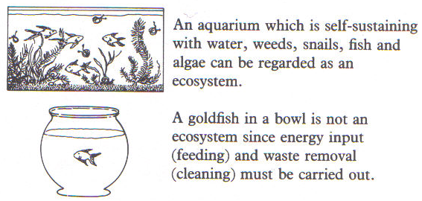

2. Eucalypts are adapted to withstand fires and yet they have some features that encourage fires to spread. (1,1,2= 4 Marks)
a Identify two features of eucalypts that enable them to survive fires.
b Identify two features of eucalypts that encourage fires to spread.
c Explain how these features together can explain the success of eucalypts as a dominant plant of the Australian vegetation.

- The diagram below describes some of the species that live in a Eucalyptus woodland ecosystem. Use the information to answer the questions below.
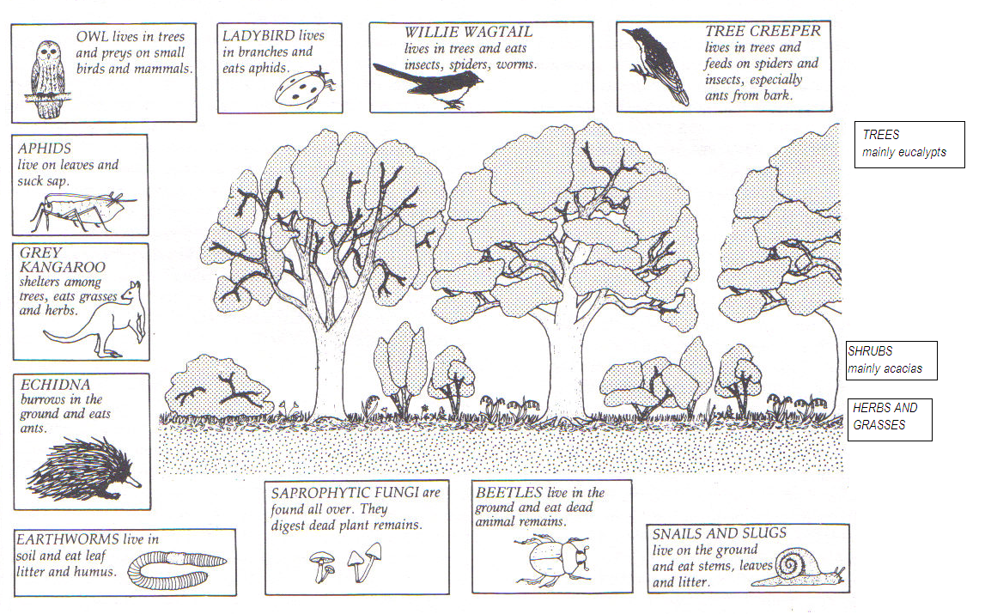
For the Eucalyptus woodland ecosystem shown above:
- Name one producer. ( 1 Mark)
- Name two first order (primary) consumers. ( 2Marks)
- Name two decomposers. ( 2Mark)
- Draw a food chain containing at least four organisms. ( 2Marks)
- Which animal is the highest order consumer? ( 1Mark)
- What is the relationship between the aphid and the ladybird? ( 1 Mark)
- Describe one effect of the removal of all of the Eucalypt trees by logging. ( 2Mark)

END OF TEST (OUT OF 37 MARKS)

